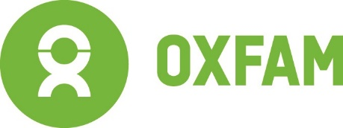
CROSS-REGIONAL GENDER GUIDE WEBINAR 2020
AGENDA
26th November 2020 3pm-5.30 Mekong / 9am-11.30 Kinshasa (DRC)
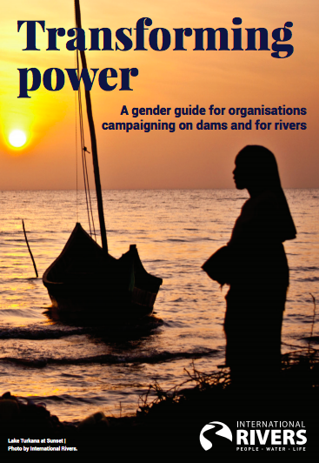
OBJECTIVES:

- an overview by some of the developers and practitioners of selected tools in the Transforming Power, A gender guide for organisations campaigning on dams and for rivers: https://www.internationalrivers.org/resources/reports-and publications/transforming-power-a-gender-guide-for-organizations-campaigning-on-dams-and-for-river/
- an opportunity to look at some of the tools in more detail and discuss experiences and potential for collaboration
- an opportunity to suggest future collaborative networks and relationships on gender initiatives

15.00: Welcome and workshop protocols
15.05: Thinking about rivers we know
15.10-16.00 GUEST SPEAKERS:
Setting the Scene in Africa and Asia: The challenges of Integrating Gender into river governance
Outline of what is in the toolkit
Firsthand experience of Implementing the tools in DRC

1600-1650: GROUPWORK: (Participants will be allocated to their preferred group wherever possible). Groups: Access to Control over Resources, Gender division of Labour, Gender impacts of dam projects, Campaign Gender Assessment
16.50-17.00 Break
17.00-17.30 Plenary: feedback from groups, discussion, next steps & closing
.

